Critical files missing from the system CentOS 7 / RHEL 7, for example /bin/mount missing

Create an issue
Become root
ls -ltr /bin/mount
rm /bin/mount
ls -ltr /bin/mount
init 6

Critical files missed from the system, example /bin/mount missing then getting an error as shown in the image below

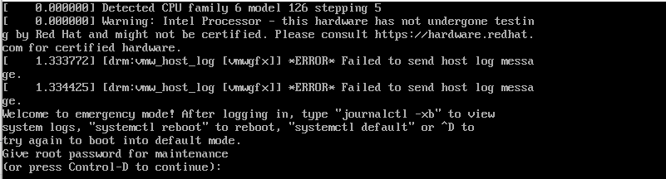

Attach dvd.iso as shown in the image below

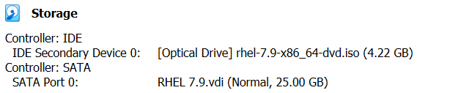

Reset OS through VM
Press Enter on Troubleshooting mode

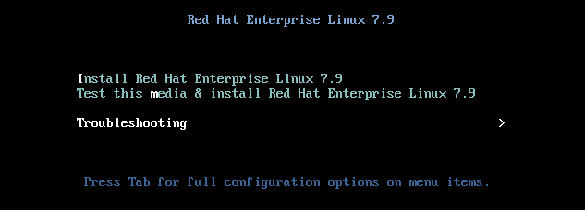

Press Enter on Rescue a Red Hat Enterprise Linux system (Rescue mode)

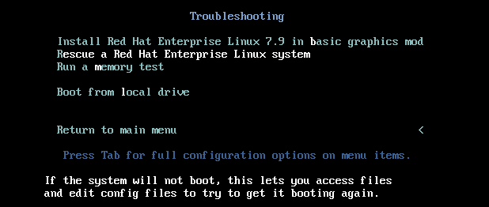

1) Continue 1 Enter

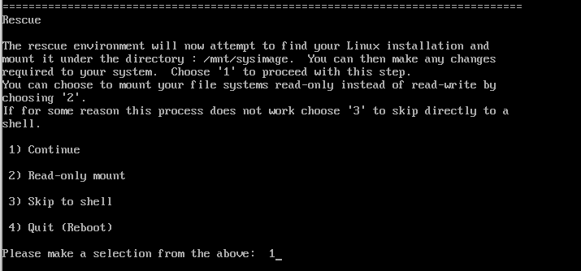

Enter

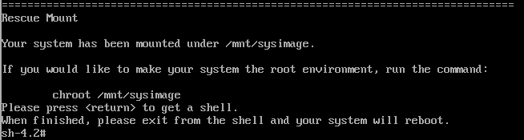

df -h

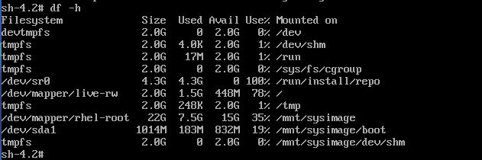

chroot /mnt/sysimage



df -h

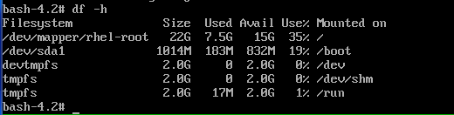

exit

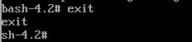

df -h

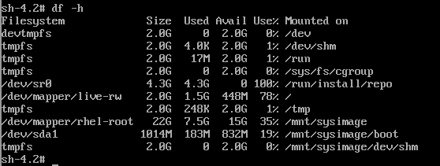

mkdir /mnt/source
mount /dev/sr0 /mnt/source

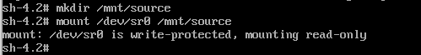

cd /mnt/source/
cd Packages/
ls -ltr
ls -ltr | grep -i util-linux-2.23.2-65.e17.x86_64
(Note: Search and find the above package from other system using the command rpm -qf /bin/mount. Install package using the below command)
rpm -ivh util-linux-2.23.2-65.e17.x86_64.rpm –root /mnt/sysimage --force
chroot /mnt/sysimage/
ls -ltr /bin/mount

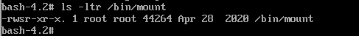

df -h
exit
df -h
cd /
umount /mnt/source/

Remove dvd.iso as shown in the image below

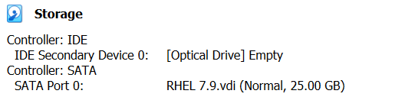

Reset OS through VM
The system is started booting up without any issue

